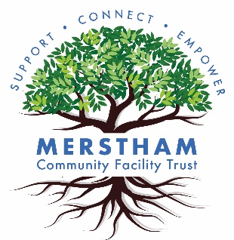

2b Portland Drive
RH1 3HY, Merstham
info@mcft.org.uk
01737 333461

Volunteer Role Description
Community Event Volunteer

Established in 2006, Merstham Community Facility Trust (MCFT) is a charity that aims to support, connect, and empower the local community. We work with the public and other organisations in a common effort to improve social welfare, health, education, employment and the general quality of life of members of the local community. Based in the vibrant Merstham Hub, MCFT provides a safe, accessible space for individuals to receive inclusive access to provisions and opportunities.

About the role:
As a Community Event Volunteer, you will be a key contributor to the success of MCFT’s events. You will be part of a dynamic and proactive team that will make agreed events and activities happen and will facilitate a space of celebration, fun, and sociability.

Activities includes:
- Preparing events
  - Planning and logistics of events
  - Promotion (posters, flyers, etc.)
  - Conducting research to make recommendations about event materials
and resources
  - Responding to participant enquiries
  - Helping pack and unpack event equipment before and after events
  - Setting up decorations, stalls, etc.
- On-the-day supervision
  - Deliver the events and activities
  - Coordinating tasks
  - Assisting event attendees (greeting, guiding, etc.)
- Clearing down decorations, stalls, etc
- Supporting monitoring event impact / gathering feedback from participants via feedback forms and surveys

Skills/Experience:
The ideal volunteer will have:
- Good team players, able to work with other staff/volunteers
- Reliable, punctual, and able to commit to agreed requirements
- Good organisational and communication skills.
- Able to communicate with a range of different groups.
- Proactive and good at problem solving.

What’s in it for you:
- Confidence, self-esteem, self-worth, and mental health improvement.
- A sense of purpose - Pride in helping others while making a difference.
- Friendships - Supporting and being part of the community and a team
- Upskilling/CV – Beneficial in your day to day including any (future) paid work.
You will gain experience in organisational skills, community engagement, and
event management.
- Gratitude - Feeling appreciated, thanked, and grounded.

Availability
- It varies. The frequency will depend on the planning and implementation of the events.

Main contact
Jeanne Constantin - Email: jeanne.constantin@mcft.org.uk - Telephone: +447526565174
Jessica Farina - Email: jessica.farina@mcft.org.uk - Telephone: +44 7526564627

